Requirements
- Device Info Write Protection Levels:
  - Perm: Level 1 (see definitions below)
  - Manufacturing: Level 1
  - User: Level 2
- Usage Counter Write Protection Level: Level 3
- Usage Counters: The device info shall implement X (?) usage counters (to be defined).
- Storage Compatibility: All requirements must be met for EEPROM, Flash, and OMMCOMM-based storage.

Encryption
- Driving Requirement: To be discussed.
  - Cyber security requirements (details remain unclear)
  - Minimum requirements: hacker cannot directly tamper with onboard sensor memory without physical change
  - Problem: they cannot copy sensor memory from one to another, but they can copy sensor memory and write it back to the same sensor memory
- Decryption:
  - Flash: needs to have the key for decryption. Use [public key + id]
- Keys:
  - Mfr has the private key for perm and mfr field
  - Firmware uses public key for perm & mfr field decryption
  - Firmware contains a symmetric key for counter
  - Key contains information about eeprom “id”, both private and public

Definitions

Data Write Corruption Protection Levels
- Level 1: Writing to this field could cause corruption of all device info fields.
- Level 2: Writing to this field could cause corruption of the field being written but not other fields.
- Level 3: Writing to this field will never cause corruption of any fields.

Usage Counter Needs discussion
- Can be incremented.
- Can be read.
- Cannot be modified in any other way.
- Possible open/close command with timestamp, increment counter after close command
- Might need to save the timestamps from open&close commands, details remain in discussion

Notes

Key Task:
- Determine how to achieve write protection level X with memory type Y.
- Provide a full matrix of solutions.

Data Protection Techniques
- Dual-Sector Memory: For Nordic MCU Flash.
- Checksum Verification: To detect and report invalid device info.
- A shallow copy on somewhere else for eeprom and ommocomm? ( read -> compose write and save copy -> write -> read -> release copy)

Store data on flash memory:
Erase size: 4k / page
Write: Single byte

Eeprom limitation:
No Erase
Write: Single byte
Use ID page to store “ID” and use it to generate encryption/decryption keys

Ommocomm:
Erase size: 2k bytes
Write size: 128 bytes
Current total memory size: 4k bytes, Could we decrease the size to 2k and use the other 2k for double buffer

Suggestions: Use perm and mfr for one page, user and counter for another page, and create a 3rd page for double buffering for user and counter

 | Flash | Eeprom | Ommocomm
Level 1 | Requires double buffer
Level 2 | Requires double buffer
Level 3 | Requires double buffer

Notes from 20250317 Meeting:
- Minimum requirement - reuse of existing device without physical tampering
  - Example: copy contents of eeprom from the sensor and re-flash it after an operation. This could be written from the plug without any physical changes to the sensor
    - Private permanent field in eeprom does not protect against this because it already exists on the individual sensor device
  - Example: copy contents of eeprom from any authentic Ommo sensor and flash it to a new authentic sensor. This could be written from the plug without any physical changes to the sensor
    - This can be mitigated on authentic Ommo hardware by using the permanent memory field in the EEPROM, but this does not solve the above example
  - without modifying or creating new hardware, you cannot copy or reset a sensor’s memory
- Ideal - protect against fake sensors or
  - Example: copy contents of eeprom from any authentic Ommo sensor and flash it to a fake/ reproduced sensor. This could be written from the plug without any physical changes to the sensor
- Encryption
  - Private ket

Notes 250319:

Attack styles
EEPROM/OmmoComm
Protocol for eeprom is in the datasheet, ommocomm protocol isn’t excessively complicated - we should assume both could be compromised
Read data, use device, write old data - Can’t prevent
Read data from eeprom 1, write to eeprom 2 - Permanent id used as part of encryption prevents this
Change usage counter directly - encryption prevents this
USB serial commands could be sniffed, known data sent to SIU, SIU encrypts, sniff data that SIU writes to EEPROM - I think none prevents key from being compromised

Flash
Flash is more secure. Encryption is not necessary. Protocol alone can protect usage counters.

In all cases the USB protocol is exposed and could be used to write data of the user’s choosing. I think this is okay as long as the counters are only incremented.
If the USB protocol was hacked you could write unencrypted data to the SIU and it would encrypt it… does this potentially expose the key?

EEPROM
Encryption serves as a signature, half key in eeprom permanently written area
Level 2 for user could be easily achieved by putting perm/man first, and never touching them again. We only need to rewrite the user section.
Level 3 for usage counters could be achieved ONLY by duplicating the usage counter itself. In addition the usage counter must be encrypted. If we are using aes128 we would need a block for the nonce and then a second block for the counter data, so 32 bytes for each counter, then duplicated so 64 bytes total.
We could consider using a 64 bit nonce and 64 bit payload to reduce this to 16 bytes * 2 per counter

OMMOCOMM
Data still goes across a fairly easy to reverse engineer protocol
Encryption should be used as a signature, We could use chip id registers for key
Full duplication of data would be the easiest implementation, but we could also store perm/man on one page and everything else on another duplicated page
Read, modify, write, erase old data

FLASH
Encryption is NOT necessary
Full duplication is required because pages are 4k

Meeting Notes 03/25/2025
- Requirement feedback from Brainlab
  - Usage Counter For MSIU
    - Incrementable counter - level 3 protection
    - Hours in state “?”
  - Instrument
    - Single timestamp for open time
    - Increment the counter on close
  - Possible implementation
    - Open: sets a PC timestamp and starts device usage time recording
    - Close: clears timestamp, increment counter
    - Get func: return timestamp & counter value

Whiteboard notes 20250317 Meeting: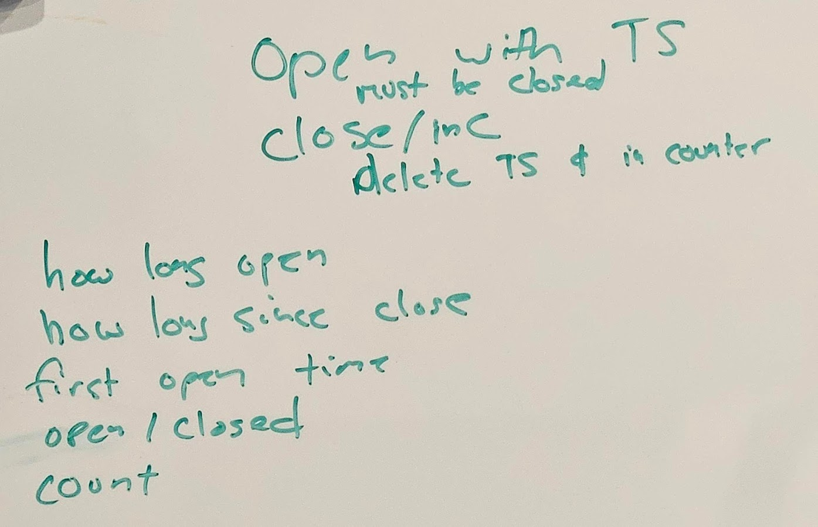
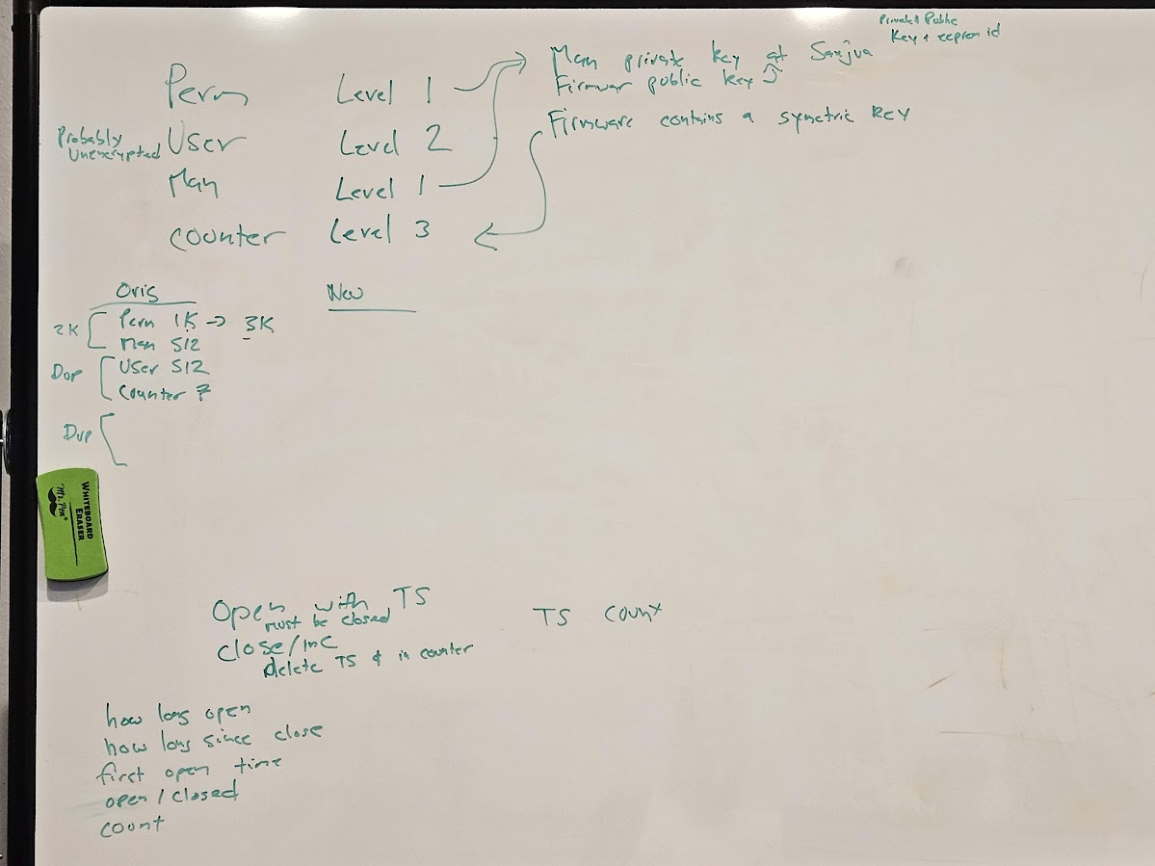

Notes 240403

Hours Counter Definition
This is repeated on both the MSIU and the ommocomm device
Time always increases while the device is powered
Has a single hours counter variable
MSIU:
Has bulk storage where time is “ticked” away during operation
Hours Counter Flush
At boot or any time the hours counter is required
- the bulk storage “ticks” are counted
- the hours counter variable is increased accordingly
- the bulk storage is erased
STM
Has a flash location for shutdown data in the Level 3 storage
At boot:
If hours_counter on either page is 0xFF’s we have failed to write to flash at power down. This should never happen, but if it does use the 0xFF page as the active page and copy the hours counter from the inactive page into memory/timer counter

The activate page is the page with the larger hours counter
Copy hours counter from active page into memory/timer counter
Erase the inactivate page
Copy all contents of activate page to inactive page except “Shutdown storage data”, leave these bytes as 0xFF’s
Continue booting

Usage Counter Definition
Has 3 variables
Count - 16 bit
Hours counter at open, 0 if closed - 16 bit
Timestamp at open, 0 if closed - 32 bit
ONLY the OPEN and CLOSE commands update these values

Ommocomm Devices (STM32)

Level 1 storage - 1 page
*Write_level1 address 0x00 here*
Perm Proto - signed protobuf with 0 term
Manufacturing Proto - signed protobuf with 0 term
Written as a pair
To read manufacturing you must read through perm data
This is exactly what we have now for device info

Level 3 storage - duplicated page - 2 pages (1 + 1 page)
Magic value - 7 bytes
Storage format revision - 1 byte
Shutdown Storage Data - 16 bytes - 1 value
Hours counter sum - 32 bit
Future Use - 12 bytes
Fixed Storage Data - 32 bytes
Open/Closed Data (Usage counter) - 3 values
Count - 32 bit
Hours counter timestamp at open, 0 if closed - 32 bit
Timestamp at open, 0 if closed - 32 bit
Future use - 19 bytes
*write_level3 address 0x00 here*
User Proto -
…
Last byte of page == 0x00 indicating valid

MSIU
Level 3 storage - duplicated page - 2x 4k pages
Magic value - 7 bytes
Storage format revision - 1 byte
Shutdown Storage Data - 16 bytes - 1 value
Hours counter sum (seconds) - 32 bit
Future Use - 12 bytes
Fixed Storage Data - 32 bytes
Open/Closed Data (Usage counter) - 3 values
Count - 32 bit
Hours counter timestamp at open, 0 if closed - 32 bit
Timestamp at open, 0 if closed - 32 bit
Device info man addr - 16 bit
Device info user addr - 16 bit
Device info total length - 16 bit
Future use - 14 bytes
Device info perm - signed protobuf with 0 term
Device info man - signed protobuf with 0 term
Device info user - normal protobuf with 0 term
…
Last byte of page == 0x00 indicating valid

Existing SIU’s
Do we upgrade?

AXON EEPROM - New
Magic value - 7 bytes
Storage format revision - 1 byte
Fixed Storage Data - 16 bytes
Device info man addr - 16 bit
Device info user addr - 16 bit
Device info total length - 16 bit
Future use - 10 bytes
Device info perm - signed protobuf with 0 term
Device info man - signed protobuf with 0 term
Device info user - normal protobuf with 0 term

AXON EEPROM - Old
Exists for read only purposes
Any write will erase all other fields (check magic number)

Commands
  - OPEN Command
    - PC:
      - Sends command with current PC timestamp
    - MSIU & Ommocomm device
      - If device is already OPEN, returns an error
      - Opens BOTH MSIU and any attached ommocomm device
      - Update Usage counter variables “Hours counter at open” and “Timestamp at open”

  - CLOSE Command
    - If device is CLOSED, returns an error
  - Update Usage counter variables “Hours counter at open” and “Timestamp at open” to 0
    - Increment usage count variable count
N/A
  - GET_USAGE_STATUS Command
    - Returns
    - Current usage count
    - Hours counter at open (0 if closed)
    - Timestamp at open (0 if closed)
    - Current total hours count

Questions:
Should firmware not allow data mode enable if device is not OPEN?

